"THE IMPORTANT THING IS NOT TO GET SEPARATED"
08 MARCH 2021

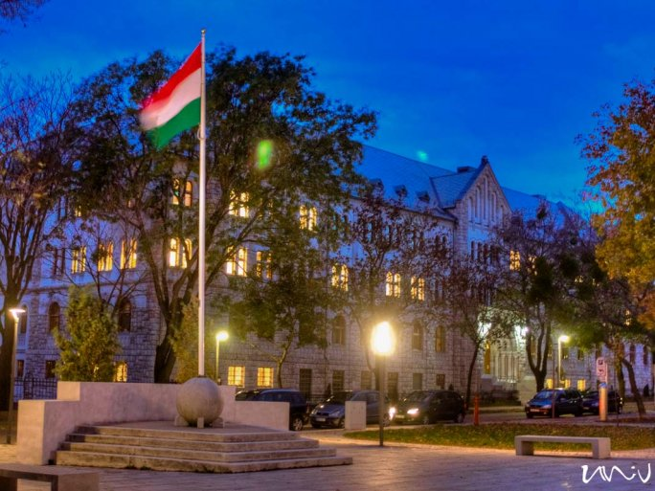
The atmosphere was buzzing at the UP Diaspora Project Network event on 5 March, which was held in the online space also due to the pandemic. It was not the first time that the UP Diaspora Project Network brought together Hungarians living across the border in the ether: after Argentina and the United States of America, this time it was Vojvodina. It was both where in the world and in what time zone the participants were at the time of the event, and the topic of the conversation, that left the geographical framework light years behind. The event was hosted by Professor Ákos Jarjabka and moderated by János Keresnyei.
An unusual health app was presented by Márton Veres. Segítség.ma was born out of an action in which Hungarian medical students screened nearly 2000 people in Transcarpathia six years ago.

"In Transcarpathia, you don't know which specialist speaks Hungarian. But it is better to be able to express your problems in your mother tongue, and access to screening is low among Hungarians anyway.

That's how the idea of the health startup Segítség.ma was born," said Márton Veres. With the app, users can search for a disease and the specialist who treats it, in relation to their place of birth. They were mainly expecting users who have been outside their country for a long time, but to their surprise, more and more first-generation Hungarians living abroad are also using the benefits of the app.

