HUNGARIAN AND CROATIAN TALENTS
18 FEBRUARY 2021.
TWITTERFACEBOOKGOOGLE+
Between 1 September 2020 and 30 April 2022, the UP Affiliated Primary and Secondary School will work together with the Josipa Kozarca Primary School (Szlatina) and the Voćini Primary School in Croatia in the framework of the TaMPeD competition, in the spirit of talent management,
to discover and develop the talents of students interested in mathematics, robotics, sports, foreign languages, and the arts.

The University of Pécs will receive €79900 of the EU grant awarded under this call for proposals
The purchases essential for the fulfillment of the tasks undertaken in the application have been made.
They have arrived:
measuring instruments and tests for talent identification;
methodological manuals and professional aids;
personality development and communication games;
3D printer and programmable drones;
sports equipment to develop endurance, strength, speed, and explosiveness.
In addition, a smart classroom is being purchased for each of the two primary schools.
Two or two talent management sessions will take place in our member schools over a ten-month period from 1 October.
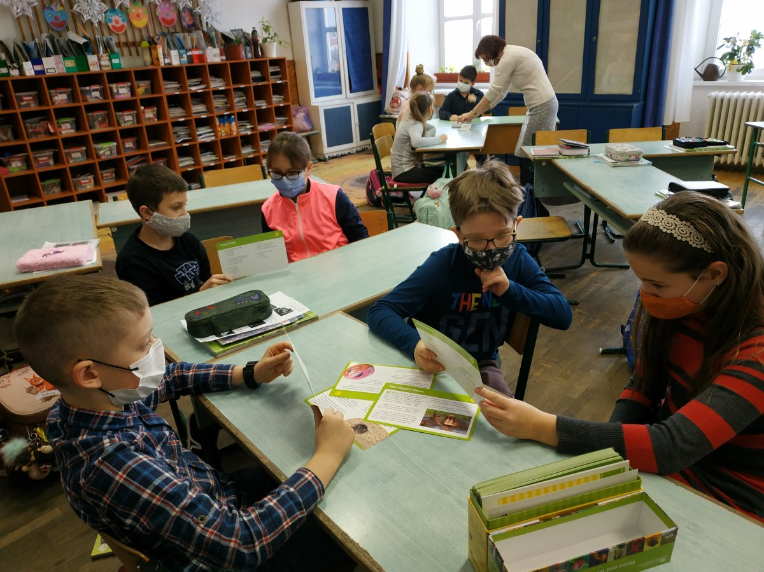
A handbook and an e-book in three languages will be produced on the talent identification and talent management activities carried out.

The program also includes a talent camp in Hungary and a talent camp in Croatia. Teachers will share their experiences in workshops and conferences.

