BE A MENTOR OF THE TEACH FOR HUNGARY! PROGRAM
13 SEPTEMBER 2021
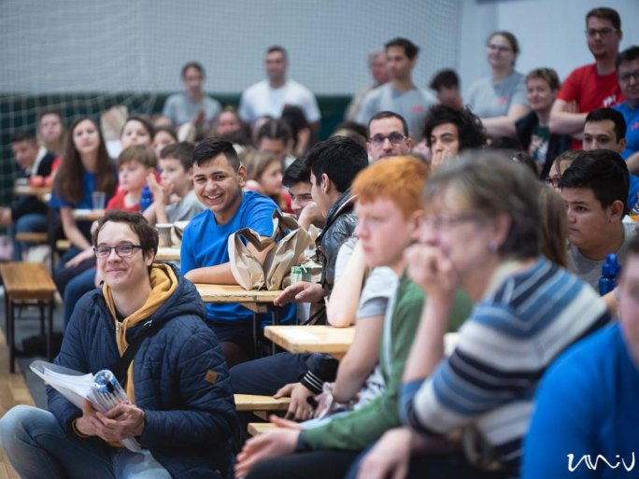
TWITTERFACEBOOKGOOGLE +
The Teach for Hungary! the program continues at the University of Pécs, aiming to give primary school children living in small villages the same chance to continue their studies or find a job as their urban counterparts.
In the program, you can also help disadvantaged pupils from small towns and cities in their studies and show them the excitement and opportunities beyond their hometown: zoos, museums, schools, and businesses, so that they can see the range of jobs and futures they can choose from.
What does the program offer for university students?
- A monthly scholarship of 30,000 HUF;
- An additional 10,000 HUF per month to spend on children and community activities;
- free travel on Volán and MÁV trains;
- participation in camps, excursions, and joint activities;
- a supportive community;
- support for small schoolchildren in small towns.
How can you become a mentor?
A prerequisite for joining is to complete the preparatory course announced in the Campus Courses: Teach for Hungary! Non-formal learning support - an elective course, after completion of which you can become an active mentor in the next semester!
The courses of the subject announced in Neptun are TANA 3000 courses, which can be registered for from Monday 6 September 2021 at 8 am to Monday 20 September at noon. The course is open to UP students of any year and any major.
Take the first step towards mentorship: sign up for Teach for Hungary! Non-formal learning support course in Neptun!

