DIGITAL TRANSFORMATION AT THE UP

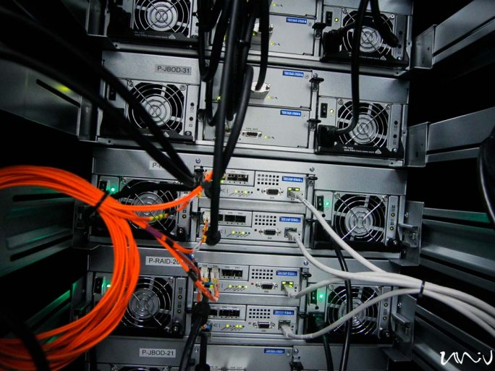
10 AUGUST 2021
Previously applied teaching and learning methods have become outdated, and the need to change and innovate has been reinforced by the need for distance learning in the wake of the coronavirus epidemic. The problem is a national one. It is an honor that the UP is growing into an important player in the national and international discourse on this issue. I asked Tamás Fedeles dr., Vice-Rector for Education, and Zoltán Vörös dr., Head of the Working Group on Supporting Teaching and Learning of the UP.
New pedagogy
"Today's generation needs to be taught and motivated differently, and these new methods need to be learned by our teachers. It's a problem worldwide, and here at the UP we are struggling with how to keep students interested," says Tamás Fedeles dr., Vice-Rector for Education, at the beginning of our conversation, and adds:
It is possible to move some elements of large-scale year-long lectures to online platforms, and rather have students be there in person at the cornerstones, but at the same time motivate themselves and get help from the lecturers. Mid-year tests can also be used to check knowledge. I think it's forward-looking to go down this road."
The end of isolation
Using digital tools in education is nothing new, and there have been many examples of this at the UP. "However, the different projects in this field were often unaware of each other, and there was no systematic follow-up: teaching and learning support materials and e-courses were created, but the knowledge was scattered." - Zoltán Vörös dr. added.
With the Education and Learning Support Workgroup, a solid team has been set up, with members who already have the right skills and competencies.
Online + present = blended
The blended learning is based on attendance cornerstones but supplemented with online opportunities and tools several times during the semester. Blended is also the chosen form of education at the UP because face-to-face contact is an integral part of the educational process.
For both instructors and students, it is easier to use fewer, but better-prepared platforms.
Motivation, motivation, motivation
With the compelling force of the epidemic gone, the current enthusiasm of lecturers may be dampened. "I think the performance evaluation system itself can be a motivating factor. After the model change, we will need a performance evaluation system that takes into account the needs of the discipline specificity, with a focus on new pedagogies, and covers the entire university. We will of course seek to reward the extra work in terms of funding." - said Tamás Fedeles dr.
"We are also trying to motivate the trainers with our website, which will be divided into sections so that trainers with different levels of training can find the help that suits their level of competence." adds Zoltán Vörös dr.

