STATE HONOURS ON THE OCCASION OF OUR NATIONAL HOLIDAY
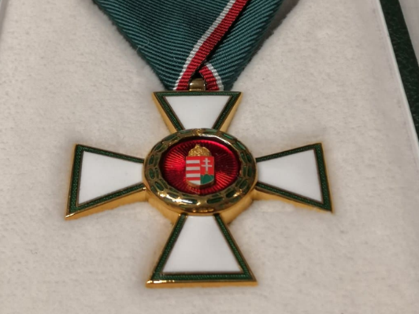
24 AUGUST 2021
State honors were awarded on the occasion of the national holiday of 20 August by the Minister of Innovation and Technology, László Palkovics on Monday at the Pesti Vigadó in Budapest.
The cross of the Order of Merit of Hungary of civilian rank was awarded to:
István Wittmann dr., Doctor of the Hungarian Academy of Sciences, clinical director of the II. Department of Internal Medicine and Nephrology, Diabetology Center of the Clinical Center of the Medical School of the University of Pécs, professor in recognition of his outstanding professional activities in the field of diabetology and nephrology, his internationally outstanding research results and his exemplary teaching and public work in the university.
The cross of the Order of Merit of Hungary was awarded to:
Zsolt Spéder dr., Professor of the Institute of Social and Media Sciences of the Faculty of Humanities and Social Sciences of the UP, from Katalin Novák, Minister without portfolio for families. President János Áder presented Professor Spéder with the award in recognition of his decades-long career as a sociologist, especially for his scientific work in the field of research on the demographic development of families, couple relationships, and childbearing.
The Knight's Cross of the Order of Merit of Hungary of civilian rank was awarded:
Jenő Gerendy dr., Munkácsy Mihály Prize-winning graphic designer, Deputy Dean of the Faculty of Music and Visual Arts of the University of Pécs, Head of the Department of Graphic Design at the Institute of Design and Media Arts, in recognition of his creative work as an artist and his educational activity, which includes the management of several professional workshops.

Emil Ludmány, violist, Associate Professor of the Department of Stringed Instruments at the Faculty of Music and Visual Arts of the University of Pécs, in recognition of his significant role in international and domestic orchestral and chamber music concert life and his exemplary work in promoting Hungarian classical music culture.
Marianna Tünde Minorics dr., Adjunct Professor of the Institute of Human Development and Cultural Studies at the Department of Cultural Studies of the Faculty of Humanities and Social Sciences of the University of Pécs, in recognition of her decades of research, teaching, and cultural outreach activities.
Gábor Szabó dr., Associate Professor at the Institute of English Studies of the Department of Applied English Linguistics at the Faculty of Humanities and Social Sciences of the University of Pécs, in recognition of his outstanding research and teaching work over several decades, as well as his internationally recognized activities in the field of foreign language assessment and language testing.
Source: kormany.hu

