MENTOR TEACHER OF THE YEAR 2021
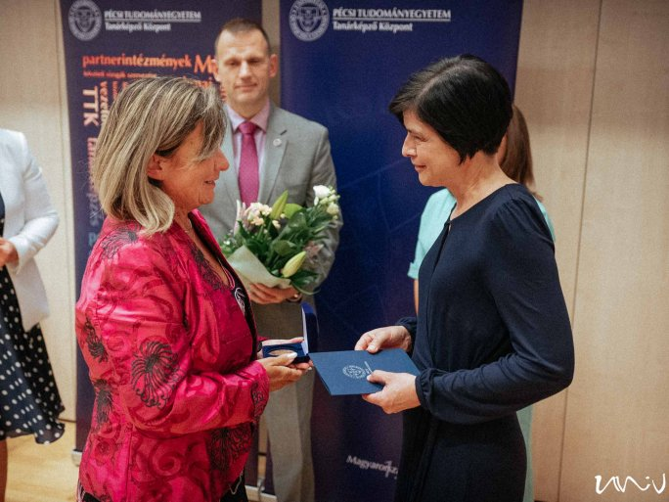
08 SEPTEMBER 2021
The Teacher Training Center of the UP awarded the title of Mentor Teacher of the Year 2021 to Krisztina Szentgyörgyi, Mentor Teacher of the Szent-Györgyi Albert Health and Social Technical and Vocational School of the Széchenyi István University of Győr, Hungary, at the opening of the academic year.
Which teacher candidates do you mentor?
Health teacher candidates, in cooperation with the UP since 2018.
What kind of personality do you need to be a mentor teacher?
I am an open-minded person, which is probably why my principal entrusted me with the mentoring task. I was happy to mentor students who came to us, and along the way, I acquired the necessary professional qualifications.
What should and can be done to help them?
The students are motivated and I am proud of them, but I need to help them with pedagogical issues. They are naturally at home in the health profession-related questions, and they practice their specialism daily, but in the pedagogical field I have to contribute a lot. We have to find a common voice with groups of 16-17-year-olds in secondary school, and they do their practical training with us.
How are the candidates taking this?
At first, you could say they are afraid, but that is more a fear of the unknown, they are all professionally prepared.
What have you gained from this training as a teacher?
I got a lot out of it, it's a very different type of teaching and facilitating job from what I do in secondary school. I get to help adults, many of them my own age and even older, learn how to teach. I feel like I've made a lot of progress in the last five years.

