THE MÉSZÁROS GROUP SIGNS STRATEGIC AGREEMENT WITH THE UP

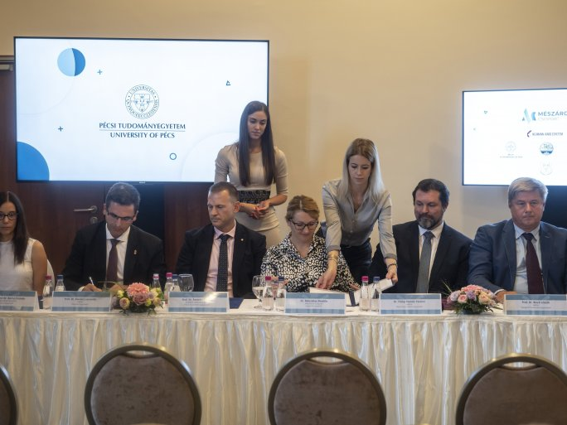
27 AUGUST 2021.
The Mészáros Group has signed a strategic agreement with the Universities of Szeged and Pécs, the Neumann János University, the University of Pannonia, and the Óbuda University - announced on Friday at the annual conference of the Mészáros Foundation in Egerszalók. The agreements aim to promote research and development on the collaborating campuses, provide practical training through joint product development and support doctoral training, opening the way to successful careers for students.
Speaking at the opening of the 5th conference of the Mészáros Foundation, László György dr., Minister of State for Economic Strategy and Regulation at the Ministry of Innovation and Technology, said: "In Hungary's leading role in economic recovery and having international success in tackling the crisis, in addition to economic policy measures, companies that have not delayed investment and innovation to remain competitive have played a major role. They have been helped by government measures to preserve jobs, create new jobs, and stimulate investment."
The opening ceremony was followed by the signing ceremony of a strategic partnership between the Mészáros Group and 5 universities in Hungary.
The universities will involve Mészáros Group experts in the educational process to provide practice-oriented training, while the Group's companies will cooperate with the universities in R&D projects, providing practical knowledge in addition to theoretical knowledge. It was announced that the program will provide scholarships for students who perform exceptionally well during their internships, and the Group will offer long-term employment opportunities to the best-performing students, thus increasing the job placement rates of university graduates.
Tamás Fedeles dr., Deputy Rector for Education, represented the University of Pécs at the event and said:
"We consider it important to bring our courses in the ten faculties more and more in line with the requirements of the labor market.
The present agreement, which aims at the joint development of practice-oriented, dual training courses, is an integral part of these efforts. For our students, the planned program will provide continuous motivation and up-to-date, high-level theoretical and practical knowledge, while for the Mészáros Group it will provide highly qualified and valuable professionals from the moment they start working." - stressed the Vice-Rector of the UP.

