**The students of architecture from Pécs promoted op-art with their installation**

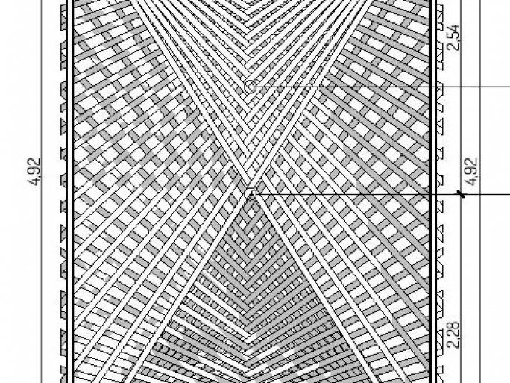

The architecture students of the Faculty of Engineering and Information Technology of the University of Pécs built an outdoor installation of colorfully painted slats in the front garden of the Vasarely Museum in Pécs, as part of the summer Museum Street Plus all-art event series. The installation, commissioned by the Department of Fine and Applied Arts of the Janus Pannonius Museum, is a spatial transcription of op-art art, and the ever-changing work, which creates exciting effects of form, space, and color, was a great success with visitors. It is therefore on display in the museum's courtyard not only during the few days of the summer program but all year round, as decided by the museum's management.

Op-art, or optical art, is based on the idea of shaping one's perception of space, which was initially achieved through painting, sculpture, and architecture. "Op-art is also important for us because it has to do with representational geometry and mathematics, but it also inspires kinetic genres and experiments in space," says Gabriella Medvegy dr., Dean of the Faculty of Engineering and Information Technology of the UP.

Perhaps the most important pioneer of op-art was Pécs-born Victor Vasarely - i.e. Győző Vásárhelyi - whose grandson Pierre Vasarely, who lives in France, is an honorary doctor of the University of Pécs and who is actively cultivating his roots and legacy with Pécs, including the university.

The idea of the installation, a joint initiative of the Janus Pannonius Museum and the Faculty of Engineering and Information Technology of the UP, was conceived during a semester course at the university. The installation was shown for the first time at the Museum Street Plus event and was loved by visitors from the very beginning, giving us a lot of positive feedback.

This was not the first time that the architecture students from Pécs have presented an outdoor installation to the public. In 2016, they drew attention to homelessness with the LAKNI KELL event, where they set up a spatial structure of aluminum drink cans representing house walls on Széchenyi Square in Pécs. The aim is to take students out of the classroom, to experience the properties of the material, the tools needed to shape it, and, ultimately, to understand the logic of construction.