BUILDING THE INNOVATION ECOSYSTEM IN THE UP HAS ENTERED A NEW CHAPTER
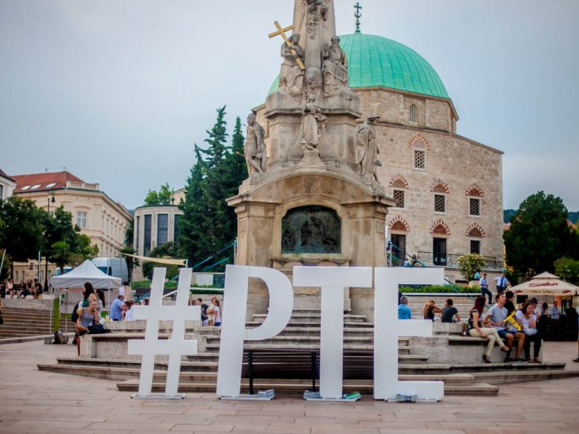
14 MAY 2021
TWITTERFACEBOOKGOOGLE+
It is now almost a cliché to say that the key to boosting domestic GDP and the competitiveness of the economy lies in strengthening the innovation process. With the establishment of the Ministry of Innovation and Technology, this process has been completed, and the Ministry has set a clear expectation for higher education institutions to integrate knowledge bases more strongly into the economy than before, thus supporting domestic SMEs in achieving their development goals. The ministry supports this strengthening partly through a shift in the funding structure, which expects collaboration between universities and companies in the allocation of innovation funds, not only for domestic development funds but also for EU funds. This process is expected to place even greater expectations on domestic universities and research institutions in the 2021-27 EU development cycle and will lead to an increasing role for these resources in the funding of institutions. For this reason, there is no way to avoid strengthening cooperation between knowledge bases and companies.
At the University of Pécs, the building of an innovation ecosystem is not new, and UP is a leader in this field in comparison with other higher education institutions in Hungary.
Another step in this effort is the launch of cooperation agreements recently signed by the UP with the Tolna County Chamber of Commerce and Industry and the Somogy Chamber of Commerce and Industry.
The aim of the cooperation agreements is, given its dominance in Pécs, to enhance the University's connection with the professional organizations of the other two counties in the region to the level achieved by the traditionally close links with the Pécs-Baranya Chamber of Commerce and Industry.
Thanks to their local roots, the Chambers can play an important intermediary role in building links between the university and local SMEs. This cooperation includes, but is not limited to, regular professional meetings, events, exchanges of experience, and joint tenders. By reaching out to companies in the regions, cooperation extends beyond research development and innovation activities to education, for example through the creation of internships and dual training modules. The chambers play a key role in reaching and mobilizing SMEs in their regions, and their services are constantly present in their daily lives. It is in the common interest of all parties concerned to get to know the development projects of local economic operators, to identify the potential for university development, to exploit possible market cooperation, and to identify joint RDI tendering programs.

