The architecture of Pécs - Two days ago, yesterday, today, tomorrow

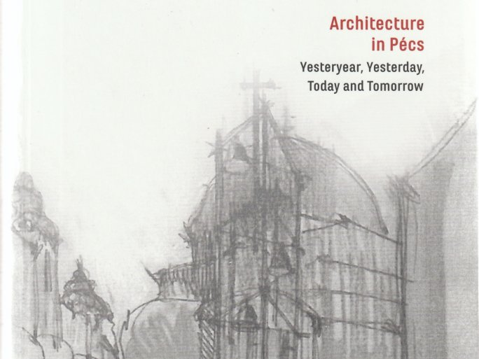

"Twenty years ago, Pécs became the first city outside the capital to offer university-level architecture education. This was followed by the doctoral level, fifteen years ago, which has now become a major center of expertise. Here, in Pécs, the birthplace of Marcell Breuer, at a more than 650-year-old university, in the European Capital of Culture, at the UNESCO-listed cradle of early Christianity, at the Mecsekalja, the artistic heritage and presence of the vibrant city have embraced the new school - and the school has allowed itself to be permeated by the environment that is its present and its future" - Gabriella Medvegy dr., Dean of the University of Pécs, opens the recently published volume of studies entitled The Architecture of Pécs - Two days ago, yesterday, today, tomorrow. Its uniqueness is that it presents the architectural aspects and iconic buildings of about 100 years of a city in a changing time, written by ten professional authors. But the book is not only for the architectural profession but also for the local patriots of Pécs and Hungary, as well as for the public who love architecture.

"Our aim in editing this volume was to open up new perspectives and viewpoints for the reader on the architecture of Pécs. We collected the contents along a time axis, which also took into account the choice of a school, and we found points of reference for the readers", says Gabriella Medvegy dr., Dean of the Faculty of Engineering and Information Technology.

