COOPERATION AGREEMENT ON ENERGY AWARENESS AND ENVIRONMENTAL EDUCATION FOR YOUNG PEOPLE

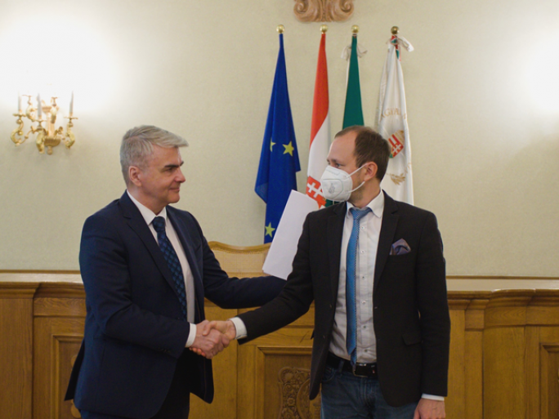

A cooperation agreement was signed between the Faculty of Cultural Sciences, Education, and Regional Development of the UP, the Baranya County Municipality, and the Hungarian Energy and Public Utility Regulatory Office for the implementation of training and professional programs to raise the environmental awareness of young people. The document was signed by Gábor Szécsi dr. prof., Dean of the Faculty of Cultural Sciences, Education and Regional Development of the UP, László Őri dr., President of the Baranya County Municipality and Péter Horváth, President of the Hungarian Energy and Public Utility Regulatory Office in the Assembly Hall of the County Municipality in Pécs.

"Climate change affects us all, regardless of national borders, and we can experience the consequences of extreme weather on our own skin."

Energy management and the preservation of our environmental values is a common causes for which we all have a responsibility. The University and the Municipality are working together to implement their joint commitment to increase energy and environmental awareness.

