BLENDED LEARNING WORKSHOP AT THE UP

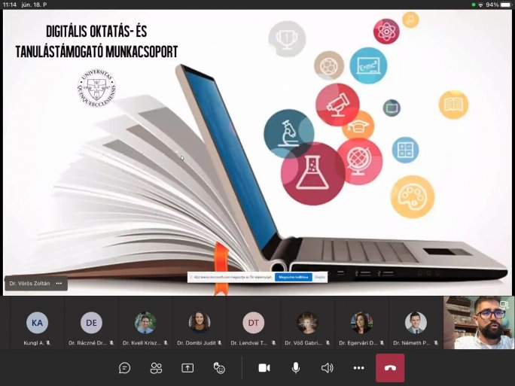

An online workshop brought the spring semester of the Digital Teaching and Learning Support Working Group's methodological training of the UP to a close on 18 June.

The aim of the organization is to promote the creation of university-wide digital teaching and learning support system for the 21st century that is responsive to current challenges.

The working group has built a Moodle training course to transform courses into blended learning methodologies. The training involved the conversion of 10 courses, with a focus on methodological support for colleagues.

The aim is to be able to support the transformation of courses methodologically and financially to the extent possible at the University of Pécs.

