**Foreigners will learn Hungarian online again this summer**

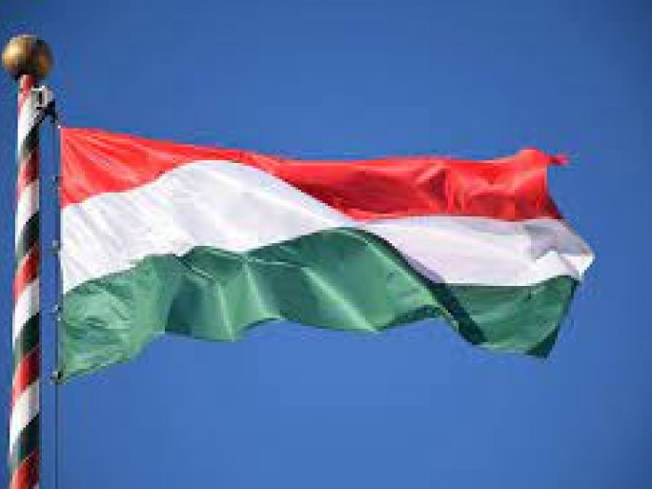

The International Education Center (IEC) of the Medical School of the University of Pécs launched the Hungarian Language and Culture Summer University 22 years ago. Similar to last year, the Summer University will be reborn online in 2021 and will be held under the title of the 2nd Digital MagyarOK Summer University. This year again, many people have chosen to study in front of their screens, with seventy people from 29 countries on four continents learning about the Hungarian language and culture or deepening their knowledge.

From 19-30 July 2021 and 9-20 August 2021, students will log on to the online learning platform for two fortnightly sessions.

Kata Pelcz said that language learning is the main focus of the online space. Students can not only find out what to learn in language classes but also how to learn it. Emphasis is placed on students being aware of what is happening, why it is happening, and how they can work in the most purposeful way.

"We are also trying to bring Hungarian smells, shapes, and tastes closer together on the web. There will be an online café, a cooking club, and a film club, we will talk about traditions, music, and history and we will also take the sights of Baranya to homes abroad."

The program can be found here:

<https://isc.pte.hu/hu/ii_magyarok_digital_s_u>