COOPERATION BETWEEN THE UNIVERSITY OF MOSTAR AND THE UNIVERSITY OF PÉCS

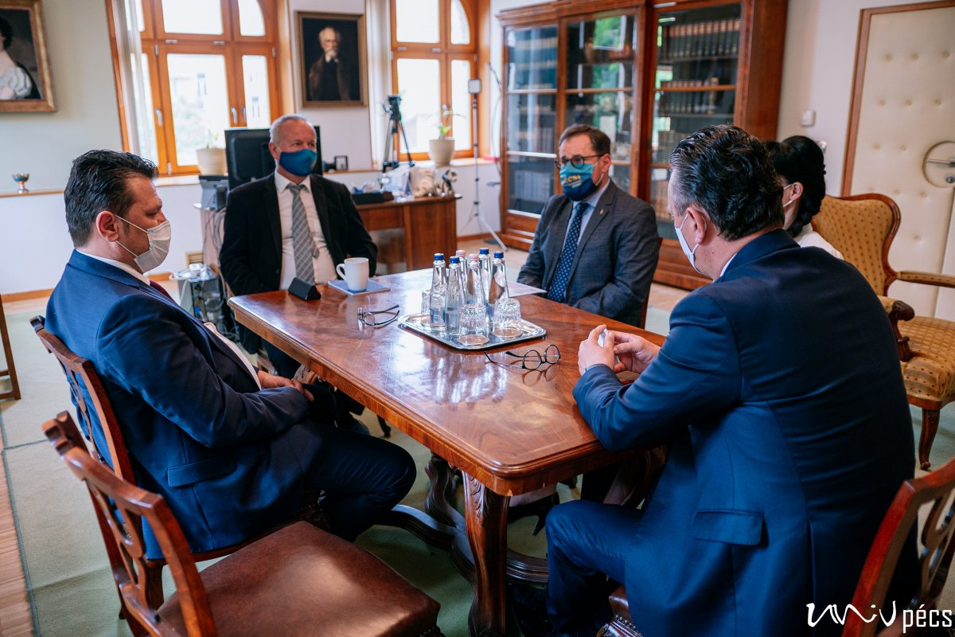

A delegation from the University of Mostar visited the University of Pécs to expand the existing cooperation. Since 2018, teacher and student exchanges and joint grant projects have been in place. Further joint programs in the field of sustainability and climate-friendly solutions are expected in the future.

https://www.youtube.com/watch?v=beZ9ezMzi5g

