THE UNIVERSITY ARCHIVES OF THE UNIVERSITY OF PÉCS WINS THE ARCHIVES OF THE YEAR AWARD!
13 APRIL 2021
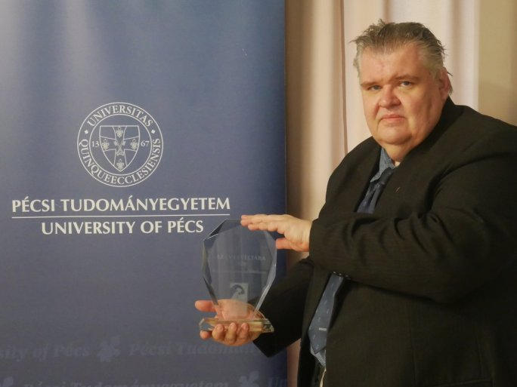
TWITTERFACEBOOKGOOGLE+
According to the decision of the Association of Hungarian Archivists, this year the University Archives of the University of Pécs will receive the professional award of the Archives of the Year. The prestigious award is given by the jury to the archival institution that has performed outstanding professional activities in the given year.
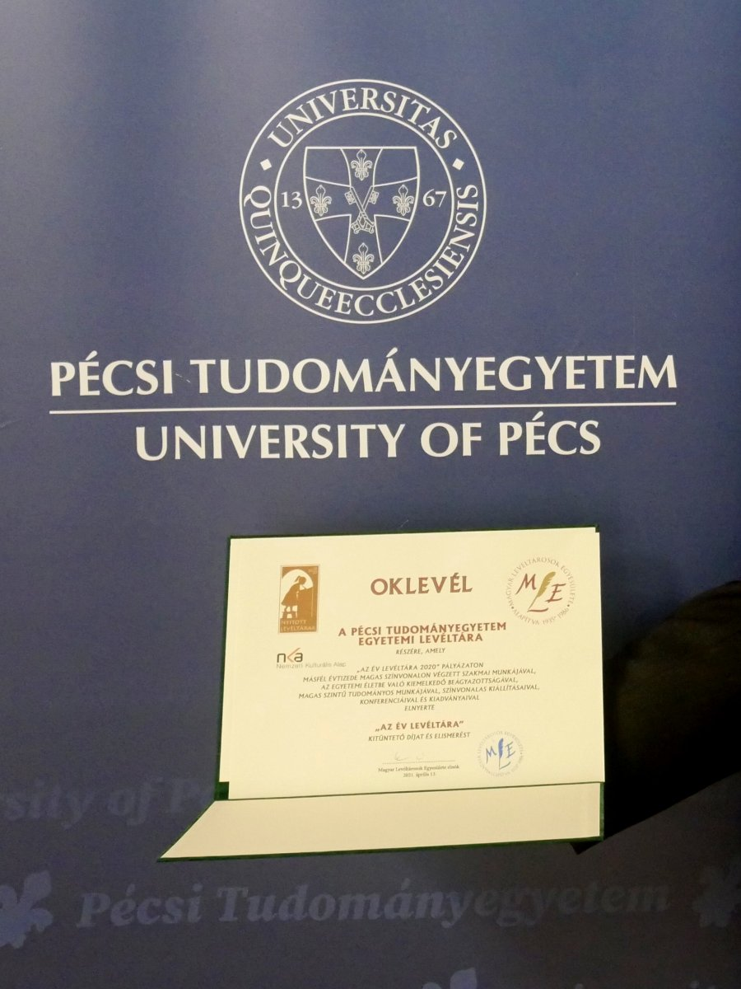
This is the first time in the history of the award that a university archive has won this prestigious professional recognition.
The jury of the Association of Hungarian Archivists unanimously awarded the prize to the University Archives of the University of Pécs based on the applications received. In their decision, they emphasized that the University Archives of the University of Pécs has been carrying out its professional work to a high standard for a decade and a half and that it is outstandingly embedded in university life and research. It has a high level of scientific excellence, as evidenced by its numerous publications, exhibitions, and conferences.

