THE NIGHT OF MUSEUMS IS WAITING!

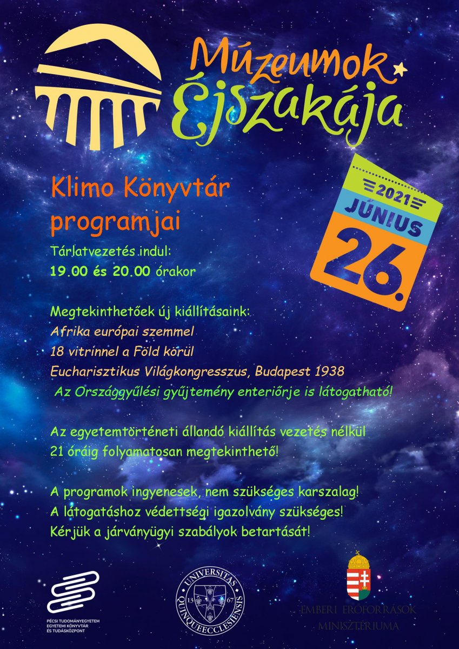

After a one-year hiatus, this year's Night of Museums will take place again on 26 June. The Department of Historical Collections of the University Library and Knowledge Center of the UP will join the event with two new temporary exhibitions.

The exhibition "18 showcases around the world" will use old books to explore the purposes of travellers from previous centuries.

The exhibition "World Eucharistic Congress, Budapest 1938", which is being held this year, will recall the events of 83 years ago, highlighting its aspects of Pécs.

