27 January 2021, Pécs

**Nearly HUF 300 million was used for the training of healthcare professionals in Pécs**

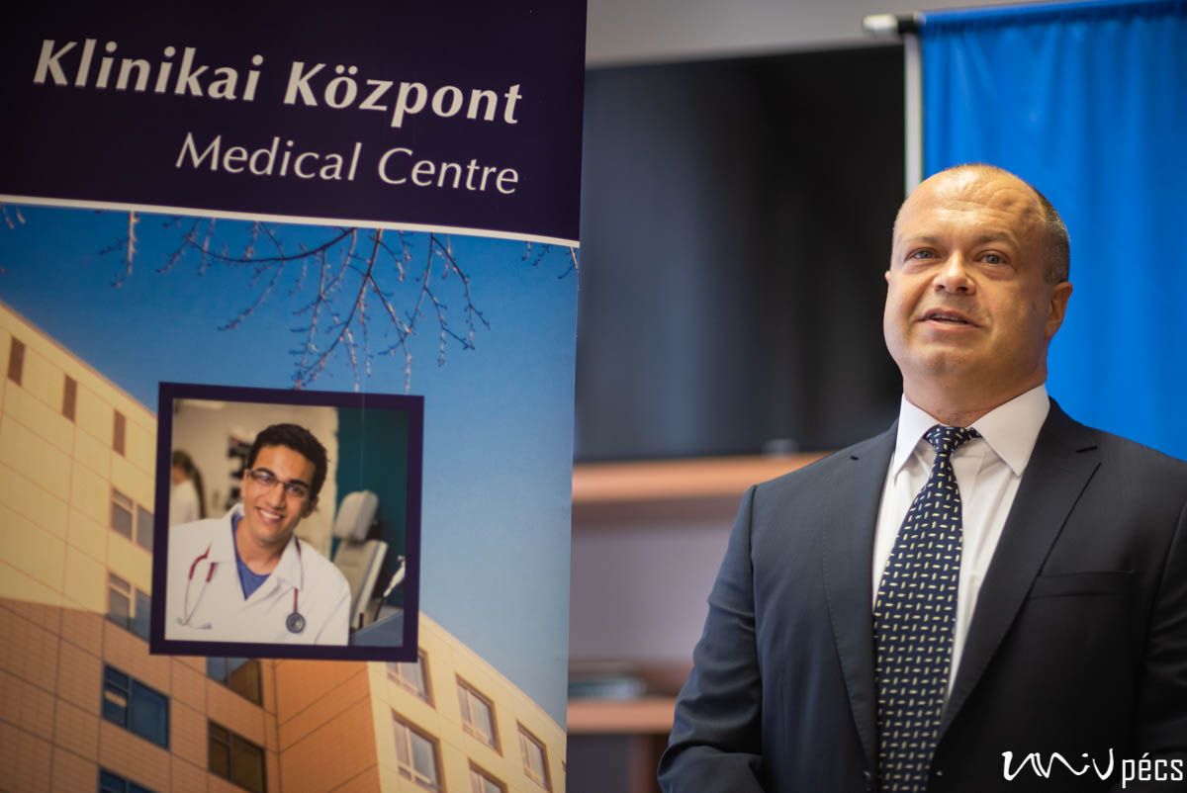

The three-year project "Continuing Professional Development at the University of Pécs", which has provided more than HUF 281 million of funding to train 96 healthcare professionals and 25 medical specialists, closes this week. Thanks to the project, the quality and quantity of human resources at the Clinical Center of the University of Pécs have improved, thus reducing the shortage of specialties.