NEW SURGICAL PROCEDURE DEVELOPED IN PÉCS IN COLLABORATION BETWEEN DOCTORS AND ENGINEERS
28 JANUARY 2021.
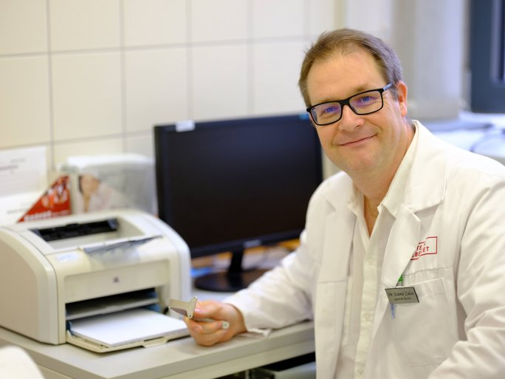
TWITTERFACEBOOKGOOGLE+
A breast surgery procedure has been further developed in collaboration between doctors, engineers, 3D designers, and metalworking experts in Pécs - and patients have already undergone their first successful operations.
A developmental disorder known as pectus excavatum, a midline indentation of the anterior chest wall, can cause juvenile maladjustment and, in more severe cases, lung and heart damage. More than 200 operations are performed each year in Hungary to correct this disorder, which affects one in six thousand children. Recently, a procedure has been developed in Pécs, using 3D technology, which is significantly shorter than before and has far fewer potential complications. The breakthrough was made possible by an almost unprecedented collaboration between doctors, engineers, 3D designers, and metalworkers, and its adoption could open up huge opportunities for surgical procedures.

