**The Children's Hospital of Pécs receives a remarkably modern ultrasound machine**

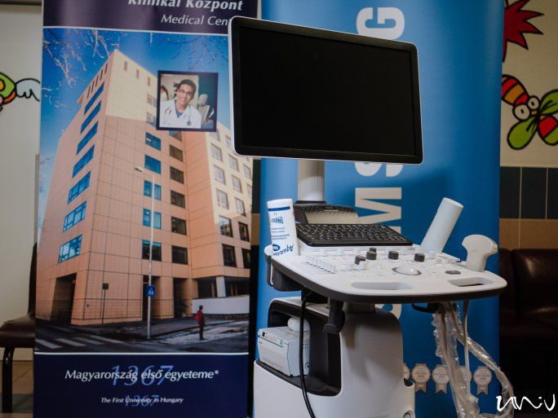

Depending on age, 5-10% of children suffer from some degree of urinary or fecal incontinence. The pediatric surgery of Pécs is a national center for patients with this disorder from all over the country. Patients are helped by a brand-new ultrasound machine, which provides doctors with much higher-resolution images and more precise examination results.

Pediatric urology is one of the main profiles of pediatric surgery in Pécs. The department has its own pressure measurement laboratory, which is an important element in the examination and follow-up of children with urinary and fecal disorders in childhood. An important link in this process is the ultrasound scan, which is used to give the doctors an accurate picture of the patient's condition.

"It is also of paramount importance for the scientific processing of the results obtained from the patients treated."

In addition to urological examinations, the acquired equipment will also enable the improvement of general radiological diagnostics.