A NEW TYPE OF HAND DISINFECTANT GEL

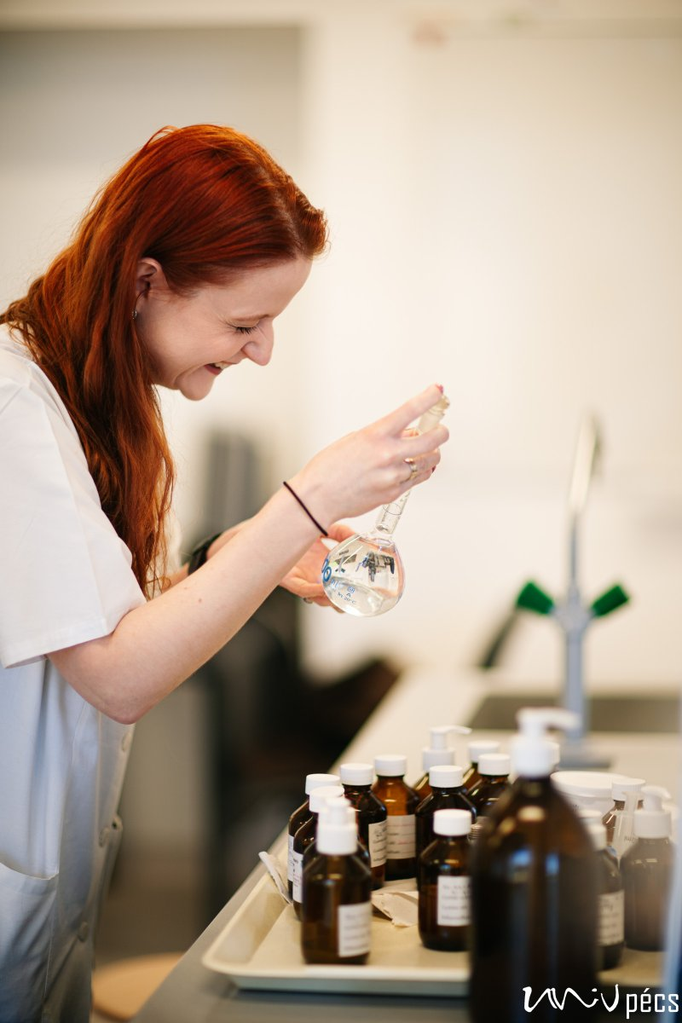

A revolutionary new way of hand sanitizers has been pioneered by a new invention, thanks to the teaching and research staff of the Institute of Pharmaceutical Technology and Biopharmacy and the Institute of Pharmacognosy of the Faculty of Pharmacy of the University of Pécs. The substance, which is made primarily from natural substances and is also effective against bacteria and viruses, is expected to be available as a product in 2021. We interviewed Anna Takácsi-Nagy dr. Ámanné, who has played a major role in the creation of the hand disinfectant gel.

How new is this hand sanitizer gel compared to previous ones?
We work with unconventional substances: the combination of active ingredients is new, as are the technological materials.

As far as I know, there is hardly any alcohol.
Indeed, it is one of the key features of our gel that alcohol is not present as an active ingredient, but as a technological aid in small quantities. Obviously, it has some effect, but alcohol is not the active ingredient per se.
What is wrong with alcohol in hand sanitizing?
Alcohol does kill pathogens, but it also dehydrates human skin.

The gel has been extensively tested by the citizens of the UP. What feedback have you received on the product and the testing itself? I don't recall a similar project before within the UP for product development. My personal experience is that many people were looking forward to trying the gel several times a day, even from the jars placed in different buildings.

Why gel and not cream?
Once you have decided what active ingredients you want, you should then decide what other substances you will use.

Will it be patented?
We are working towards that, yes. The UP has included the product in its Intellectual Property Portfolio in 2019 and obviously, we would like to go further, as such protection is a step forward in the international market.

