FEVER-PHOBIA PARADOX - OR HELP FROM THE FEVERFRIEND
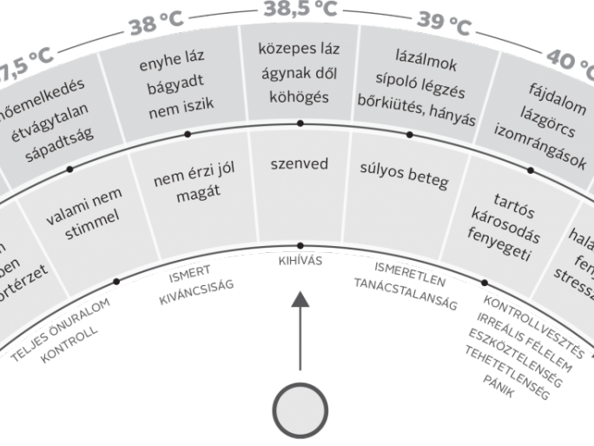
Henrik Szőke dr. is the head of the FeverFriend program, infant and pediatrician, assistant professor, and acting head of the department at the University of Pécs. Together with a team of nearly 20 people - doctors, health, sociological and pedagogical experts, programmers, and experienced parents - they have developed a modern telemedical application (FeverFriend) based on a decision-support algorithm and a knowledge base for information.
As a practicing dad, I know that when a child gets a fever, the excitement immediately increases and the question arises: should the fever be controlled or not? How can an app like this help? Does it decide for us?
It is well known that the link between fever and the immune system is very close. We find that if we reduce the fever with medication, we also reduce the operation of the immune system to some extent. We no longer need to explain why we need to reduce fever, but the other way around: we need to examine and explain why, what is the reason, the evidence, and the consequence of interfering with our small, stable, self-healing function.

