INTERNATIONAL SPRING - MAY PROGRAMS

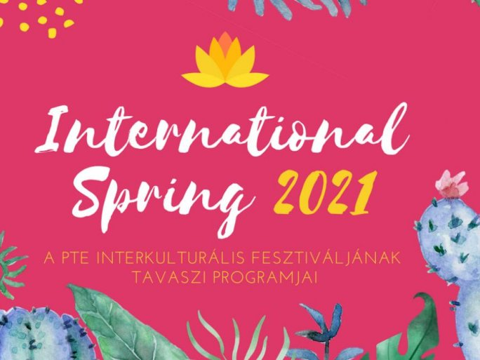

May is also the month to take part in the International Spring. The list of events will be updated continuously!

https://www.facebook.com/InternationalSeasonsPTE

