BENDEGÚZ, THE WHEELCHAIR GLOBETROTTER - HOW DOES HE PUSH THE BOUNDARIES OF THE WORLD?

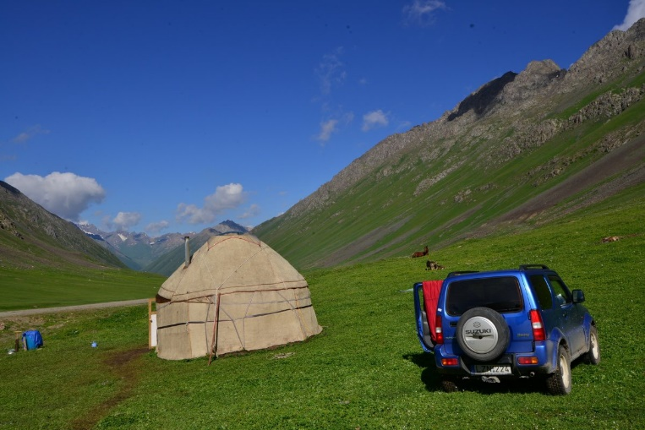

Bendegúz Lóránd Nagy has spinal cord injury. But that's not the first thing you think of him, because he has travelled the world. His car, a Suzuki called Jimmy, is the only thing that helps him most of the time. Or not even that: he hops on a plane and then travels to the most remote parts of the world, alone in his wheelchair, bumping on buses or by himself. As part of this semester's International Spring, an online exhibition of his photographs taken in Central Asia is on display, due to the coronavirus. I asked him why and how he pushes the boundaries of the world.

Why do you long to travel?
It's good to travel, sometimes you have to! The great explorers, when asked why they travel, have always answered "Because the world is there". There is no need for a longer or more elaborate explanation than that."

How did you get started? Did you immediately set your sights on other continents? What places have you been to?
As I should, I first travelled through Transylvania and Hungary, then, in ever-widening concentric circles until I ran out, Europe, followed by Asia, and much of North and Latin America.
Where are you travelling or planning to travel next and why? And where, if anywhere, do you not plan to go - and why?
I've grown very fond of Africa, and I'm always keen on going back there.

"I don't have a bucket list when I go for months at a time, as I have a lot of time on my hands, I'm mostly writing and doing photography. It's not the pushing of the button that excites me, it's getting to that point where I get there."

