EXEMPLARY TEACHERS AT A SENSITIVE UNIVERSITY - TÍMEA EISNER DR.
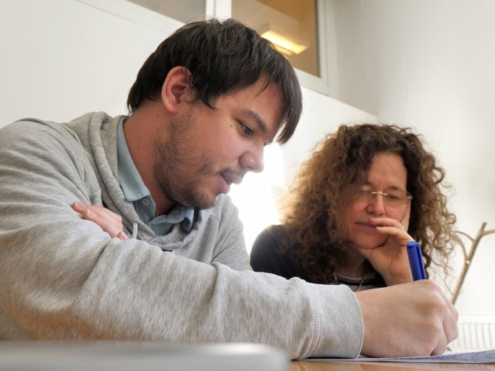
The University of Pécs has previously developed the Sensitive University strategy, which specifically aims at the higher integration and more successful academic prosperity of students with special needs. According to its strategy documents, our institution aims to become an "Inclusive" and "Sensitive" university. Of course, this is an objective that will require a lot of work to achieve. Setting a good example is a guide and an incentive to follow. We would like to highlight those lecturers who have shown themselves to be sensitive, and helpful and who have explicitly tried to provide help adapted to the learning difficulty in terms of methods, curricula, examinations, devoting more energy, time, and opportunities to the students in need, not least with understanding, acceptance, and empathy for successful learning. Our series aims to set a good example and thus make the university environment more inclusive.

