ETHIOPIA AND GHANA IN HUNGARY
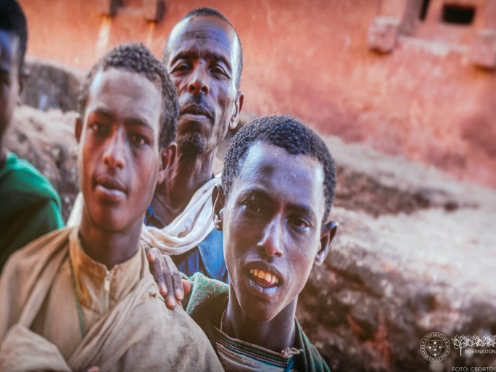
The Africa Week kicked off on 16 May as part of the International Seasons program of the International Directorate of the UP. This year's opening day included a photo exhibition in the Knowledge Center and a lecture by Zoltán Ginelli.
At the opening of the exhibition, it was revealed that there are three things that all Ethiopians feel it is important to say about their country:

- Ethiopia has never been a colony, even though Mussolini has tried to colonize it, and has always managed to repel these attempts.
- Their capital is to Africa what Brussels is to Europe. Addis Ababa is the capital of the African Union and they are trying to move the destiny of the African continent forward, reinforced by the pan-African idea.
- Their pride is in the tradition and culture of the country speaking more than 80 languages.

