COULD YOU MANAGE A COMPANY?
15 FEBRUARY 2022.
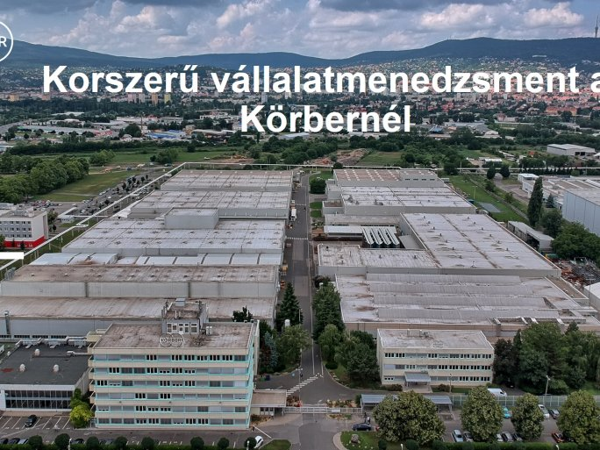
It's never happened before! Learn about company management through an engineering company. The classes are held by Körber Hungary Engine-builder Ltd., which guarantees interactivity and real-life examples.
This is the first course linked to a large company from the Baranya region, but the company has already had many links with the UP. The course is offered for campus credit, so it is open to students from any faculty or department of the UP.
The course is structured around three themes:
Quality, environmental, and energy management systems
This provides a framework for the life of the company, allowing students to learn about and experience first-hand the operation of Körber's management systems through practical exercises.
Project management
The focus is on managing change effectively, through the presentation of real case studies in group work.
Lean and production management tools
The priority goals of the company's life and the factors that hinder them are presented. Students will practice through modern problem-solving methodologies.
Students who take the course will also get a personal insight into the life of Körber Hungary: factory visits and discussions on practical experiences will be organized, where they can put the theoretical knowledge gained in the course into practice.

