BREAD AND WATER IN 2022, AFRICA
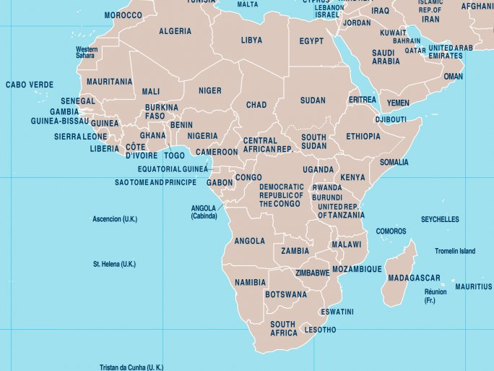
Perhaps the two most fundamental factors for humanity were discussed on 19 May at the Africa Week conference at the Knowledge Center in the framework of International Spring. Rashed Daher analyzed the impact of the Ukrainian-Russian war on the food situation in Africa, and in particular in Egypt, while Ráhel Czirják presented the results of a study on the impact of a specific project on a water supply unit set up by the Maltese Relief Service in the Kibera district of Nairobi.

