ABOUT THE PAKS II PROJECT
02 MARCH 2022.
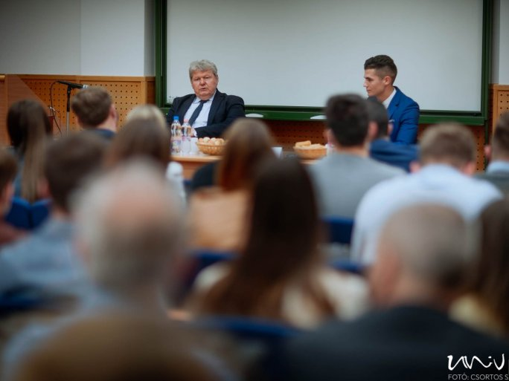
TWITTERFACEBOOKGOOGLE+
János Süli, the Minister of State without portfolio responsible for the expansion of the Nuclear Power Plant of Paks, gave a presentation on the Paks II project at the Irk Albert Lecture Hall of the Faculty of Law of the UP on 28 February. The event was jointly organized by ELSA (The European Law Students' Association) and the Faculty of Law of the UP.

