A SMART T-SHIRT IS ALSO BEING DEVELOPED AT THE FACULTY OF ENGINEERING AND INFORMATION TECHNOLOGY OF THE UP
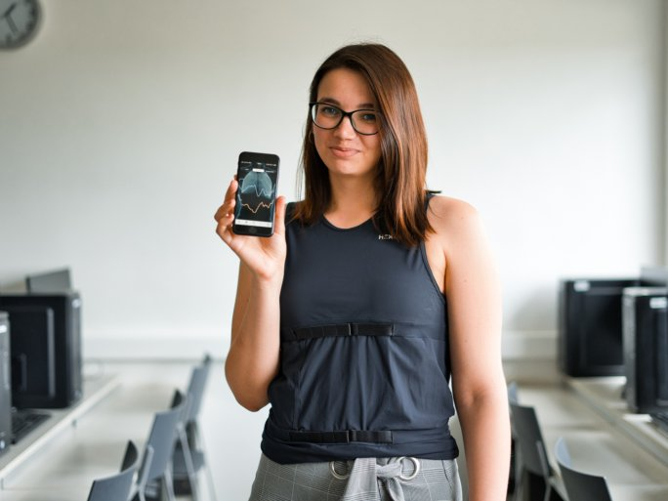
Real-time monitoring of vital parameters on people wearing smart t-shirts, the investigation of the possibilities of colour correction of image data using statistical methods - these are just two of the 12 winning applications supported by the Huawei SEEDs Excellence Scholarship Program at the Faculty of Engineering and Information Technology of the University of Pécs. The Huawei Technologies Hungary set up a research and development fund at the beginning of the year to provide students with technological tools and to encourage them to pursue their research, development and study goals. In the recently closed competition, 25 applications were received, of which 12 were selected and will be implemented by the young people in the coming months. They will present their ideas at the Science and Arts Students' Conference in the autumn, and one or two of them may even become marketable products.
The global technology company Huawei's SEEDs Excellence Scholarship programme offers future engineers the chance to gain important hands-on experience, as well as to conduct interdisciplinary research and get involved in the development of digitalization demos. In all this, students and student teams are supported by mentors.
Many of the ideas submitted are based on artificial intelligence (AI), for example, AI processes the physical parameters of smart T-shirt wearers into valuable data.
Participation in the Excellence Scholarship Program develops students' problem-solving skills, project work and teamwork, which will give future engineers a strong advantage in the job market.
Students in Pécs can also benefit from the Huawei ICT Academy program, which was launched in the autumn and offers new opportunities related to next-generation mobile networks, 5G technology, the latest networking tools used in the industry and artificial intelligence.

