A GIRDLE CAN ALSO BE PRINTED ON THE UP

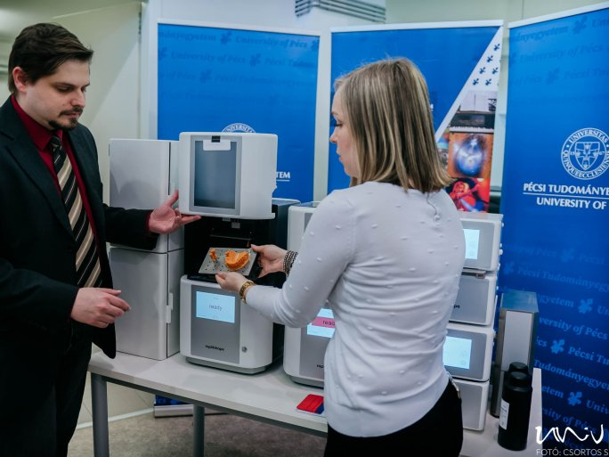

The 3D Printing and Visualisation Center of the University of Pécs has been enriched with two up-to-date three-dimensional printers. It was announced at a press launch on Monday, that the new printers solidify liquid resin using laser light, which is one of the most cost-effective and up-to-date processes in the world of 3D printers. The new devices can be used to produce gum models, dental arch models, dental surgical drill templates, dental crowns, and bridges, and orthodontic and bite-raising splints, among other things, to support dental training at the UP.

As well as striving for high-quality education, treatment and research, the institution must also keep pace with technological developments. Our 3D center is a clear demonstration that we do not treat this as a fad, but take it seriously," he said.

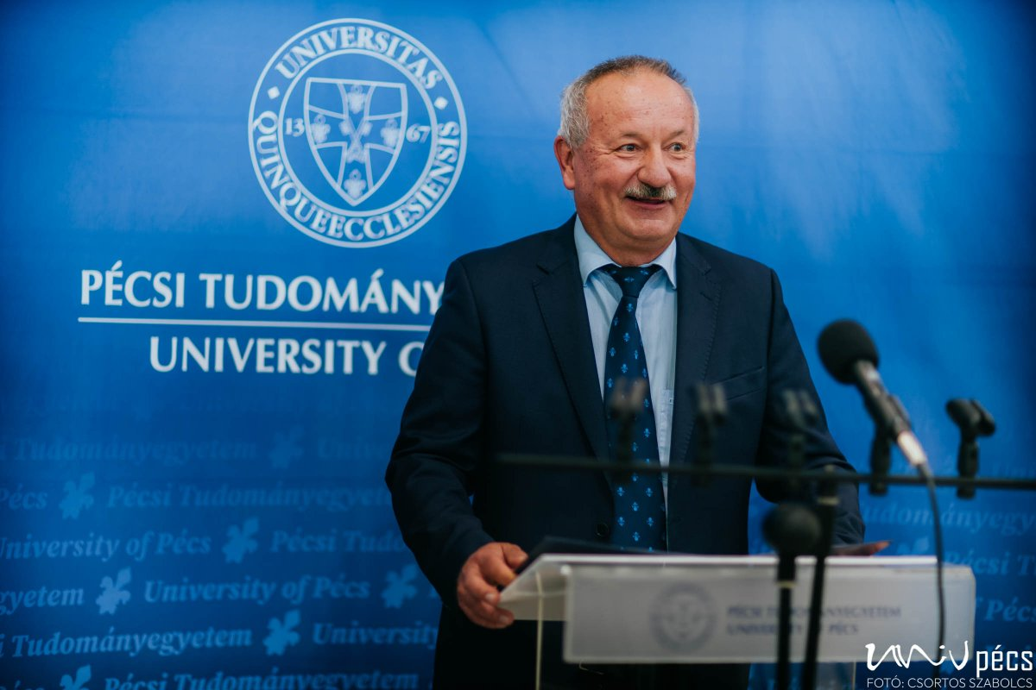
Rector Attila Miseta

According to István Decsi, Chancellor of the UP, practice-oriented training should be supported by all means, as it is the only way to obtain a truly valuable degree. "Today, buildings are made with a three-dimensional printer, which a few years ago was only in the category of science fiction."

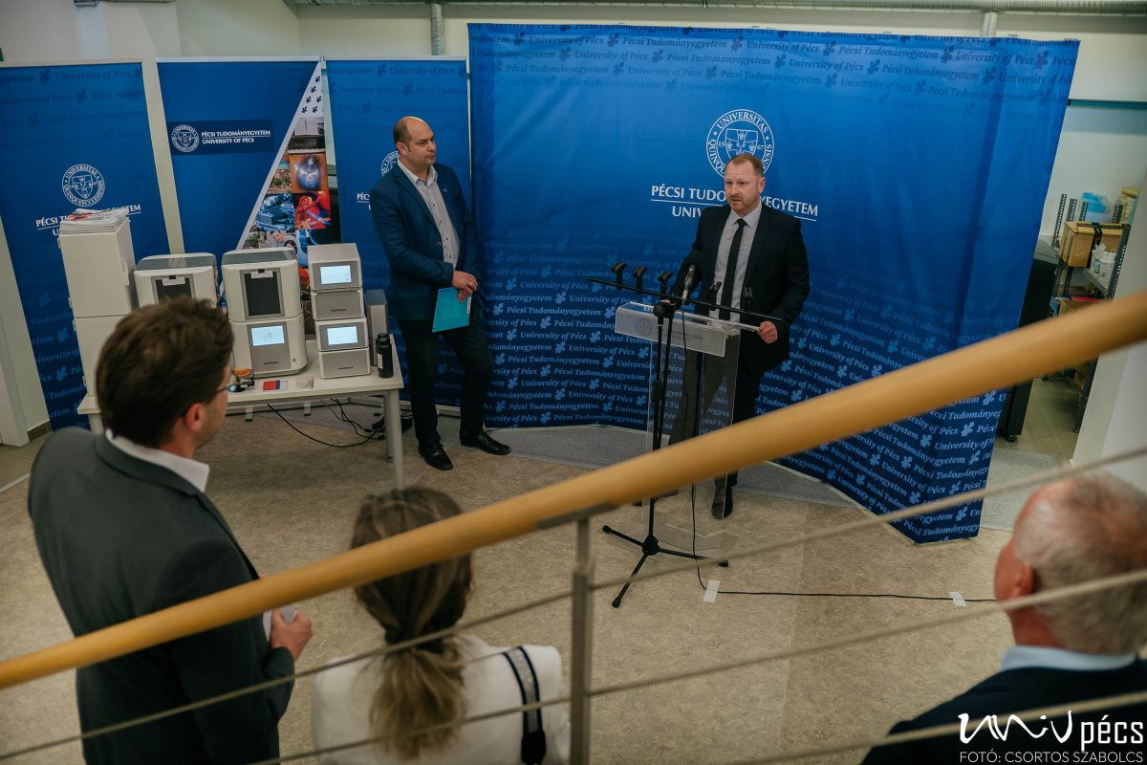
Chancellor István Decsi

