A DOCUMENTARY WAS MADE ABOUT THE HEROIC WORK AT THE UNIVERSITY OF PÉCS DURING THE CORONAVIRUS
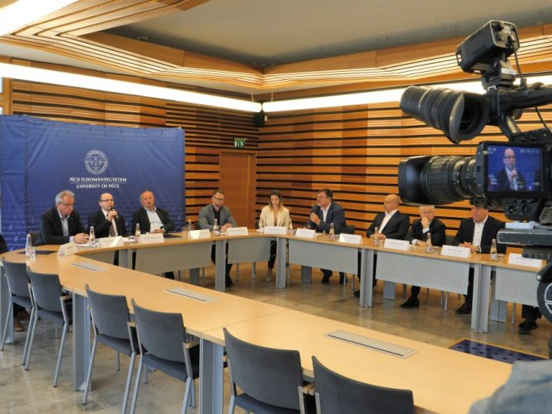
The normal functioning of the University of Pécs was disrupted in an instant by the emergence of the coronavirus epidemic in Hungary. Immediate solutions had to be found for the isolated care of infected patients, the safe working conditions of staff, and the education of students without the possibility of attending classes. There were only a few days to evacuate all the dormitories, to reorganize the university's education into the digital space, and, with the advent of vaccines, the specialists set up the vaccination point in a very short time. Meanwhile, researchers raced against time to find the most effective cure for the virus.
The film shows the concerted and sacrificial work that experts have been doing since the beginning of the epidemic. The actors talk about the difficulties of the past period, the often seemingly impossible tasks, the nights that have been worked through, the complete overhaul of education, and the role of the pandemic in building community. The activities of professionals are revealed, from laboratory medicine to emergency care, from virology to intensive care, in almost every field where colleagues have tried and are trying to reduce the impact of the epidemic and help combat it.
To tackle a crisis of this scale and find a long-term solution required an unprecedented level of collaboration. This collaboration and work are captured in a documentary on the UnivTv of the UP, in which frontline workers talk about their experiences of past outbreaks.

