8 COUNTRIES, 3 CONTINENTS, 25 STUDENTS: SUMMER UNIVERSITY ON THE CHALLENGES OF THE EU
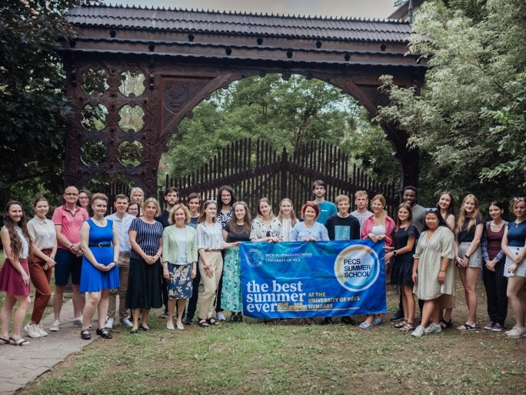
Interactive lessons about the European Union, intercultural evening, a visit to the Zsolnay Quarter, sightseeing by train, excursion to Orfű, and events at Sétatér - this year again exciting programs await the summer students at the University of Pécs. For the sixth time now, the CEEPUS program is supporting a summer university on the current challenges of the European Union, this year entitled "Europe in the Global Arena - 2022". This year, 25 students from universities in the Czech Republic, Croatia, Slovakia, Austria, and Moldova will participate in the courses. Foreign students from member universities will also be involved in the course, representing a total of 8 countries and 3 continents. The special interdisciplinary 10-day course will examine how the European Union can maintain its role and competitiveness in the face of global challenges.
The speakers come from a wide range of disciplines (political science, economics, cultural studies), and the professional presentations are always followed by discussions. As part of the course, students will formulate their expectations and ideas about the European Union, proposing solutions to the political, social, and economic difficulties and opportunities identified.
In addition to a serious professional program, the organizers also place great emphasis on providing students with a wide range of cultural activities after the lessons.
In 2022, the Pécs Summer School program will offer 7 courses. The increasing number of summer university programs has made UP a market leader in this field among Hungarian higher education institutions. In 2021, the UP has won the EAIE Excellence in Internationalization award, the most prestigious European recognition for its successful short-cycle international programs.

