3 MORE SUMMER UNIVERSITIES!
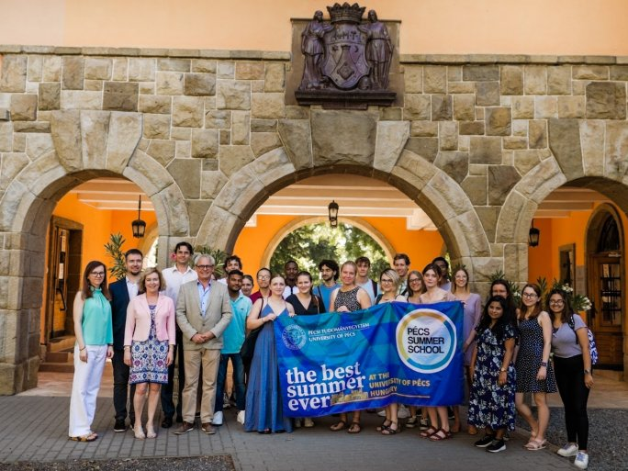
The legal aspects of the application of artificial intelligence, current issues of data protection law, intercultural knowledge, and the cultural heritage of Hungary - with the participation of 100 students, another 3 summer schools started this week at the University of Pécs within the framework of the Pécs Summer School program.
In addition to the German, Italian, Czech, and Russian partner universities, Hungarian and foreign students from the UP will participate in the two-week summer course named Law and Technology, where they will learn about current issues of data protection law and the legal and ethical challenges of artificial intelligence applications. The program is organized for the second time for students of the European Digital University City (EDUC), by the European University Association. The academic program is provided by the Faculty of Law.
Also launched this week is the four-week program for students from the French university ESIEA, which is being organized for the first time this year as a result of a new university partnership. The 40 French students will participate in four weeks of English language and intercultural training offered by the Faculty of Humanities and Social Sciences.
In parallel with these programs runs the two-week summer university "Cultural Heritage of Hungary", which will be held online this year. Participants will be students from partner universities in the Czech Republic, Russia, Ukraine, Indonesia, Albania, and Greece, and will gain a comprehensive knowledge of Hungarian history, economy, cultural heritage, and folk music. The academic part of the program is provided by the Faculty of Cultural Sciences, Education, and Regional Development.
There will also be a wide variety of leisure activities for participants in the online program. These include an online city tour, an intercultural evening, a games night, and an online cooking show, where students can learn how to cook goulash soup.

