Sustainable procurement policy
Introduction
The University of Pécs sets its procurement policy in line with the sustainability guidelines set by the Public Procurement Authority.
Goal
The University has set a new vision, policy, and strategy for environmental sustainability as a goal, raising the University’s profile in sustainability policy and practice.
As part of our overall strategy, we have set ourselves the task of ensuring that all people, processes, goods, services, and works are carried out in a way that takes into account the appropriate environmental considerations within the University.
Our ambition is to integrate sustainability as a fundamental principle into the entire procurement process, assessing and defining procurement needs, in the field of selecting suppliers, evaluating offers, and post-contract management.
Objectives
The objectives of sustainable procurement are:
- complying with all relevant legislation and regulatory requirements and the Authority’s guidelines
- promoting sustainable awareness and evaluation among suppliers and contractors
- procurement of sustainable products and services
- reducing the environmental sustainability impacts of construction and renovation projects
- taking environmental, economic and social considerations into account when specifying goods or services; contracts for goods should include the possibility to buy environmentally friendly products
- sustainable criteria to be used when evaluating potential suppliers’ offer
- promoting awareness of sustainable issues and considerations in the user community
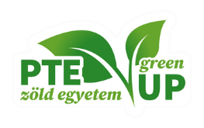
Further guidance for areas related to sustainable procurement is available on the website of the Green University Program of the University of Pécs: https://zoldegyetem.pte.hu/en

